 **National University of Computer & Emerging Sciences, Karachi**

**Department of Computer Sciences**

**Mid-Term Examination (Fall 2019)**

**17 October 2019**

|  |  |
| --- | --- |
| **Course No: CL 118** | **Course Name: Programming Fundamental** |
| **Instructor Name / Names: Atiya Jokhio and Maham Mobin Shaikh** | |
| **Student Roll No:** | **Section: E** |

**Time Allowed**: 90 minutes. **Total Marks**: 30

Instructions:

* Attempt all questions, read each question completely and use your question paper for rough work.
* After completion of exam, return the question paper.
* Your Student ID must be written on the paper.
* In case of any ambiguity, you may make assumption. But your assumption should not contradict any statement in the question paper.
* If any question regarding paper, you may ask within 5 minutes after starting paper.
* For Exam submission: Create a folder named **“your student-id” i.e. (K19-0100).**
* Paste the .c file for each question named as **Q1.c, Q2.c** and on so in that folder.
* Convert the folder into zip.

**Question # 1:** *[ Marks: 8 Time:25 mints ]*

Write a C program to input electricity unit charge and calculate the total electricity bill according to the given condition:  
For first 50 units Rs. 0.50/unit  
For next 100 units Rs. 0.75/unit  
For next 100 units Rs. 1.20/unit  
For unit above 250 Rs. 1.50/unit  
An additional surcharge of 20% is added to the bill.

How to calculate electricity bill to find electricity bill.

**Question # 2:** *[ Marks: 7 Time:20 mints]*

1. Draw a following sequence using function.



**Question # 3:** *[ Marks: 7 Time:20 mints]*

Dujana’s teacher give him an assignment to find whether a number is perfect or not. He studied and repeated his basic concepts and find that a perfect number is a positive integer that is equal to the sum of its proper positive divisors, excluding the number itself. Write a program in c using **recursion.**

**Question # 4:** *[Marks: 8 Time:25 mints ]*

Draw a following pattern using C coding

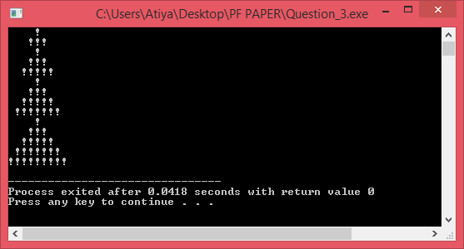

**BEST OF LUCK!**